Mental Health Support

NHS Support
You don’t need to have seen a doctor before calling for NHS support with mental health.
Different support is available depending on the individual:
- Cognitive Behavioural Therapy
- Counselling
- Online Groups
- Self-Guided Help
You can be contacted via a means that is best for you:
- Face to Face
- Telephone
- Video call
- Online
Waiting times are short
If you are registered with a GP in Blackpool call 01253 955 700
If you are registered with a GP in Fylde or Wyre call 01253 955 943

Every Mind Matters
This NHS campaign provides a range of resources to support individuals with metal health problems
https://www.nhs.uk/oneyou/every-mind-matters/
Support is categorised into:
- Coronavirus
- Anxiety
- Low Mood
- Stress
- Sleep
- Parents
- Youth
- Urgent Support
- Possible Causes
Every Mind Matters

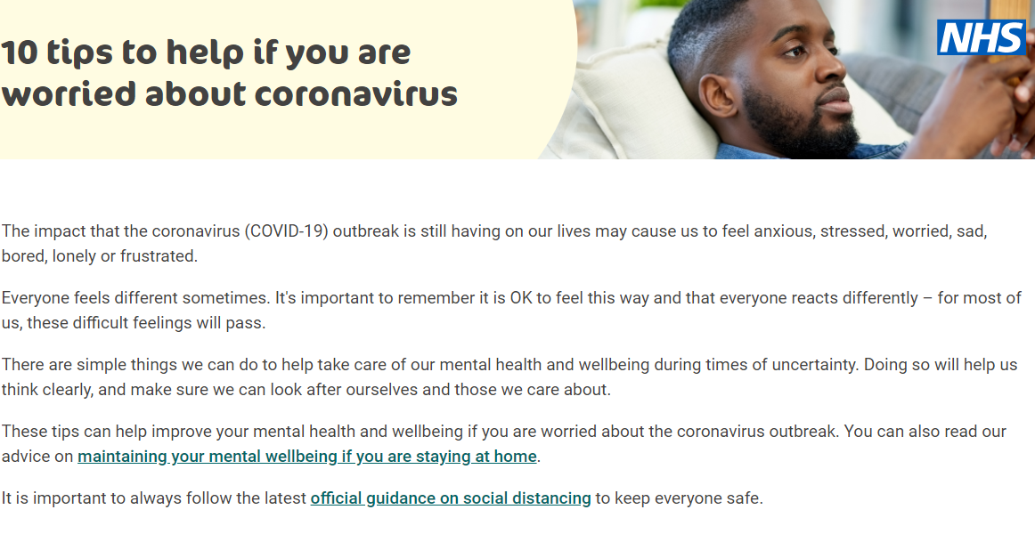

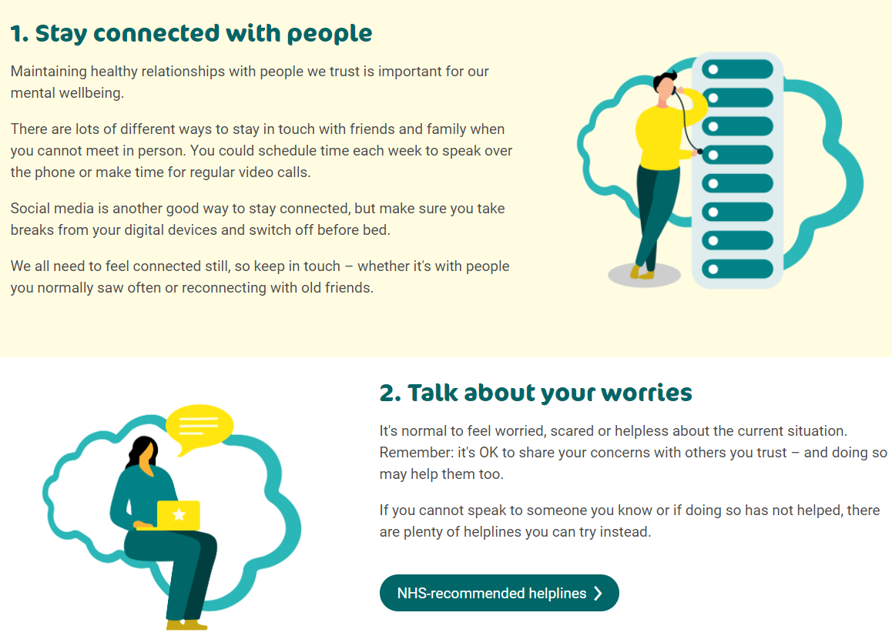

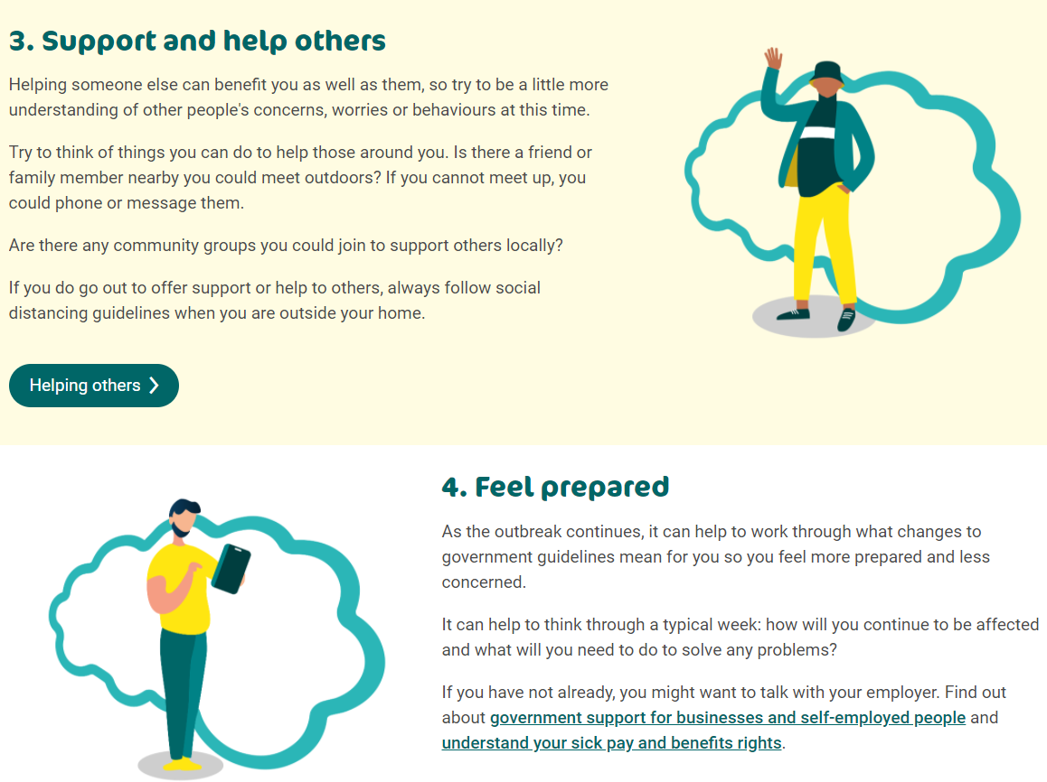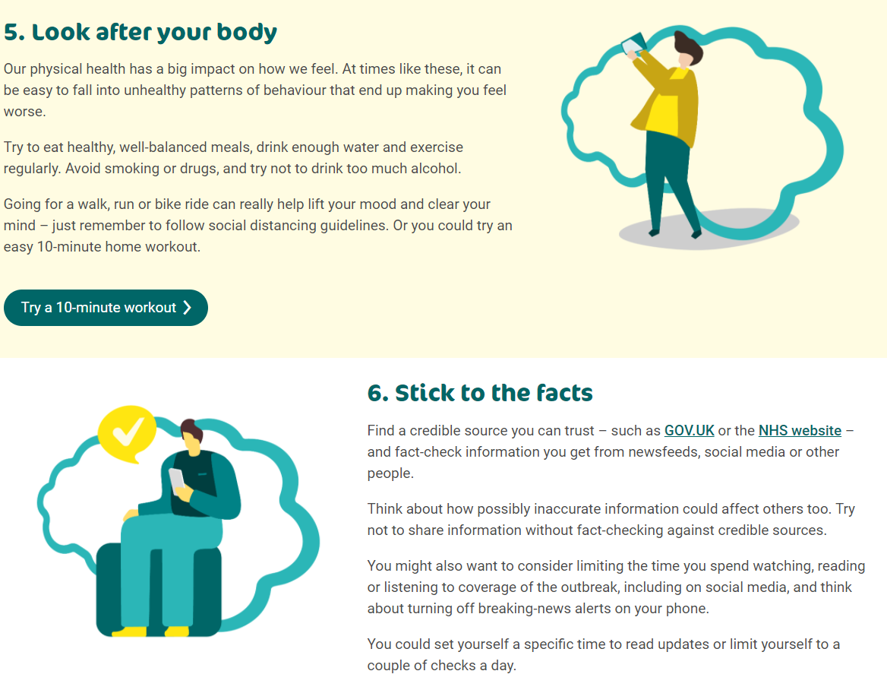
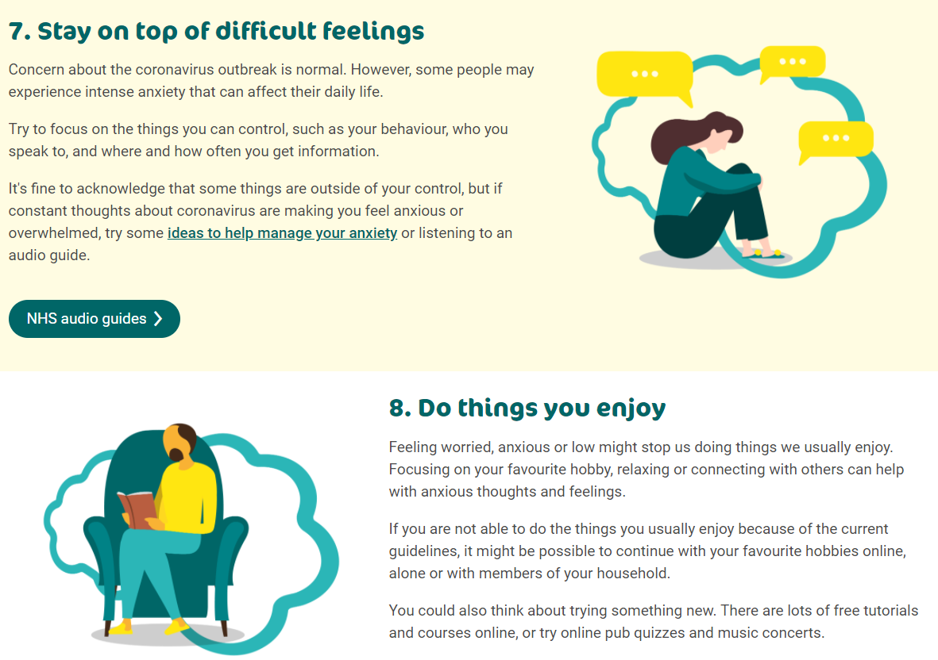
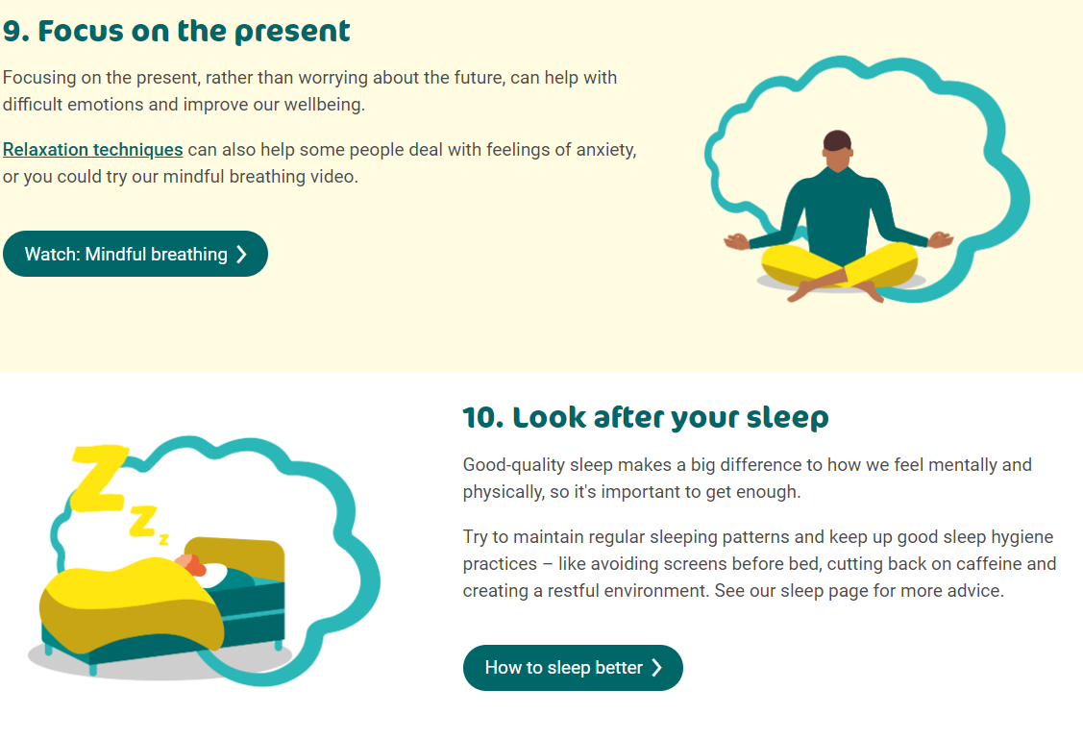

Non- NHS support
There are also a range of charities and specialised support services available to people struggling with their mental health.
Services noted on the next 2 pages may have changed due to COVID
Information has been taken from https://www.healthierlsc.co.uk/mentalhealthsupport

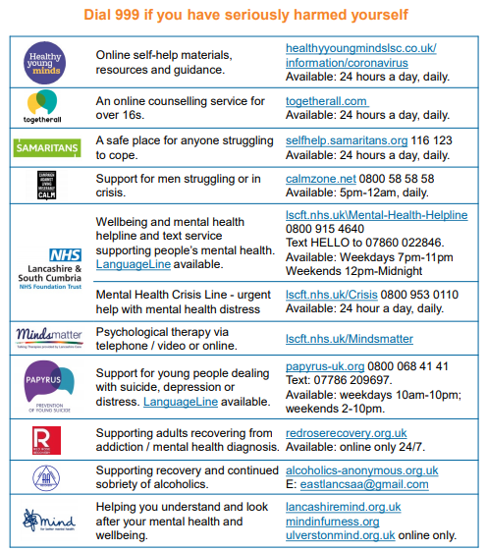
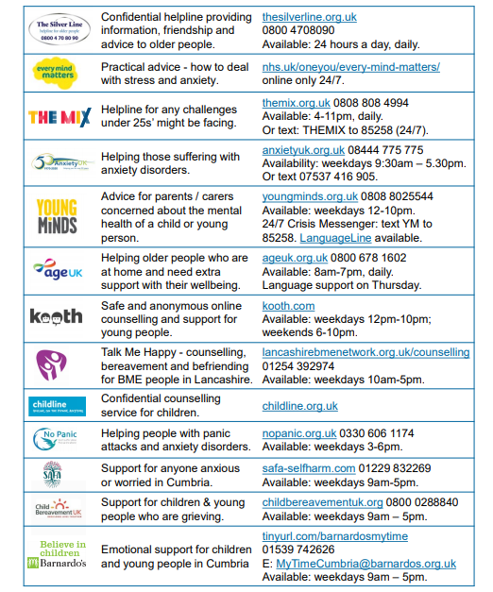

Other Sources of Information

More information regarding CCG services
https://www.fyldecoastccgs.nhs.uk/local-services/mental-health-services/
https://www.bfwh.nhs.uk/our-services/supporting-minds/

NHS Every Mind Matters
https://www.nhs.uk/oneyou/every-mind-matters/

Healthier Blackpool
https://healthierblackpool.co.uk/getvocal/

Healthier Lancashire and South Cumbria
https://www.healthierlsc.co.uk/mentalhealthsupport

Our Lancashire
https://ourlancashire.org.uk/about/about-us/

